**CS39440: Project Outline – Burnt area detection with satellite images.**

By Jovan Radan (jor75)

Supervisor – Natthakan Iam-On (nai7)



Degree Scheme:

GG47 – BSc, Computer Science and Artificial Intelligence (with integrated year in industry)

Release Date: 29/01/2024

Submission Date: 12/02/2024

Version: 1.0

Status: Final

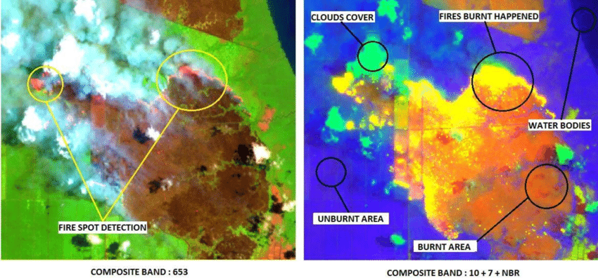

# Project description

**What is this project about?**

***What is the main substance of the project?***

This project is about using Artificial Intelligence (AI), specifically deep learning, to help detect/prevent forest fires in Southeast Asia.

Forest fires are a big problem in that part of the world (ASEAN). This can cause climate change, endanger human lives and health, hurt animals and plants, destroy property, critical infrastructure, and cultural heritage, as well as the loss of timber and biodiversity and have severe impacts on the economy and environment, which is why we need to be able to find them quickly and easily.

I will develop a program using satellite images to find burned areas and areas susceptible to wildfires. Satellite imaging will help by covering vast amounts of areas quickly and repeatedly, providing timely and comprehensive data on burnt areas, especially in remote or inaccessible regions. This is crucial for rapid response and resource allocation in wildfire situations.

The program will use Machine Learning (ML, specifically deep learning) to learn what burnt areas resemble in satellite images. ML algorithms can automate the analysis of complex spectral patterns and learn from large datasets, leading to more accurate and objective burnt area detection than visual interpretation. Making it less subjective and prone to error, thus leading to saving significant time and manpower compared to manual interpretation.

This may also be used to examine past burn patterns and long-term satellite data. ML models can be used to detect high-risk wildfire locations, which can aid with resource planning and preventative actions. In addition to being useful for post-fire management and recovery activities, the data may be used to evaluate the extent of burns and calculate their environmental effects.

This project is perfect for me as I want to advance my knowledge in machine learning and satellite image analysis, as this has some link to what I did in my industrial placement, in which I was very engaged. It also helps to protect the environment and save lives.

Within this project, I will do research on the following:

* Satellite-image-deep-learning
* Segmentation
* Free data sources
* Sentinel 2 Bands & Combinations
* Image classification

# proposed tasks

***Indicative tasks*.** This data science project consists of the following tasks.

1. Literature review for background and related work,
   1. Burnt area detection: problem definition, process.
   2. Sentinel-2 images – bands and combinations
   3. Data preparation process
   4. Data modelling process and commonly used detection models + pre-trained models
   5. Model evaluation metrics
2. Analysis framework design and implementation,
   1. Collect public datasets (with labels)
   2. Design experiment
      1. Data sets
      2. Methods + parameters
      3. Evaluation metrics
3. Satellite image collection (e.g., Sentinel-2) and data preparation,
   1. Explore public data sets of satellite images (with labels)
   2. Perform data exploration and preparation.
4. Model evaluation and parameter analysis,
   1. Perform experiments.
   2. Compare results using appropriate evaluation metrics.
   3. Perform more experiments on parameter analysis to get the best parameter setting/best results.
5. Documentation and report (with a possible manuscript draft).
   1. Report
   2. Python Scripts/Modules/Packages
   3. Manuscript (if interested)

# project deliverables

**Blog –** To make a weekly blog summarising the work that has been completed and what wasn’t done or is still in progress. Explain what happened, the challenges faced, how to overcome them, and more.

**Project Report –** To have a concise overview of the project, including its objectives, methodology, key findings, and conclusions. Which can be understood by anyone, regardless of their technical expertise.

**Source Code –** To have a well-documented source code, to have the files organised logically and accompanied by clear comments and documentation explaining functionality, design choices, and usage instructions. Use a version control system, “Git,” to allow tracking of changes and reversion to previous versions if needed. Testing to demonstrate the flexibility and correctness of individual code modules.

**Technical Documentation –** A more detailed report providing deeper insights into the technical aspects of the project. Including sections on data acquisition, pre-processing, processing, model development, evaluation, and result. Some of the results will include visualisations and figures to aid understanding.

# initial annotated bibilogogrphy

1. Satellite-image-deep-learning <https://github.com/satellite-image-deep-learning/techniques>

Deep Learning techniques applied to satellite and aerial imagery. It covers various tasks like classification, object detection, and change detection, providing references to datasets, models, and software frameworks.

For example:

· 2.4.5. [IndustrialSmokePlumeDetection](https://github.com/HSG-AIML/IndustrialSmokePlumeDetection) -> using Sentinel-2 & a modified ResNet-50

Detecting industrial smoke plumes in satellite images  
Using machine learning at NeurIPS 2020 workshop  
Potential applications: environmental monitoring, air quality, emissions

· 2.4.6. [burned-area-detection](https://github.com/dymaxionlabs/burned-area-detection) -> uses Sentinel-2   
  
This project uses AI and satellite images to find burned areas after wildfires, aiding early response and environmental tracking.

· 2.4.11. [burned-area-baseline](https://github.com/lccol/burned-area-baseline) -> baseline unet model accompanying the Satellite Burned Area Dataset (Sentinel 1 & 2)

Comparing burned area detection algorithms on satellite images  
Uses Sentinel-2 & Sentinel-1 data with pre-existing benchmarks  
Includes UNet model and separability index calculations

1. 15 Free Satellite Imagery Data Sources <https://gisgeography.com/free-satellite-imagery-data-list/>

This article from GIS Geography offers a comprehensive list of free satellite imagery data sources available for various purposes.

1. <https://medium.com/@northamericangeoscientistsorg/deep-learning-for-satellite-image-classification-with-python-ceff1cdf41fb>

This article demonstrates building a convolutional neural network (CNN) in Python using Keras to classify satellite images from the UC Merced Land Use Dataset.

1. <https://www.kaggle.com/datasets/abdelghaniaaba/wildfire-prediction-dataset>

Canada’s website for original wildfires data. Contains satellite images (350x350px) in 2 classes:   
Wildfire: 22710 images  
No wildfire: 20140 images.

1. <https://www.kaggle.com/code/bloodaxe/deep-learning-for-satellite-image-processing>